Familiar with anaconda environment

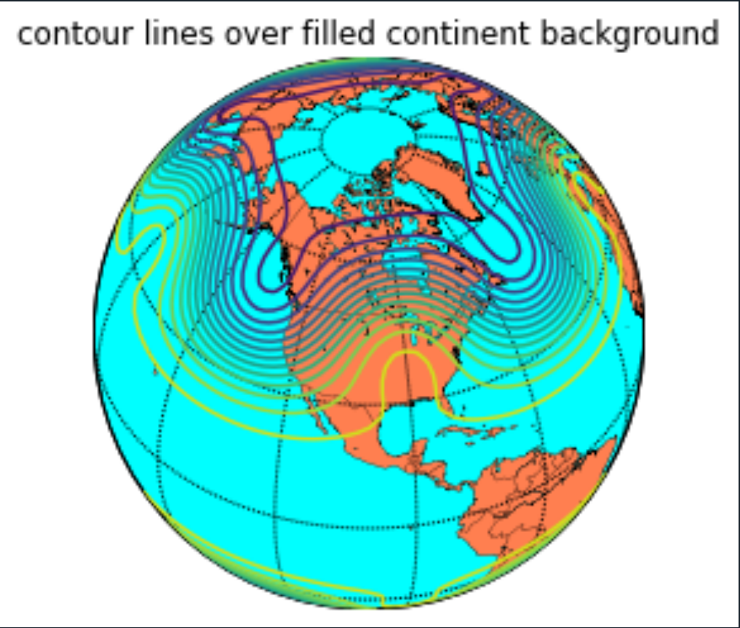

Without augmentation

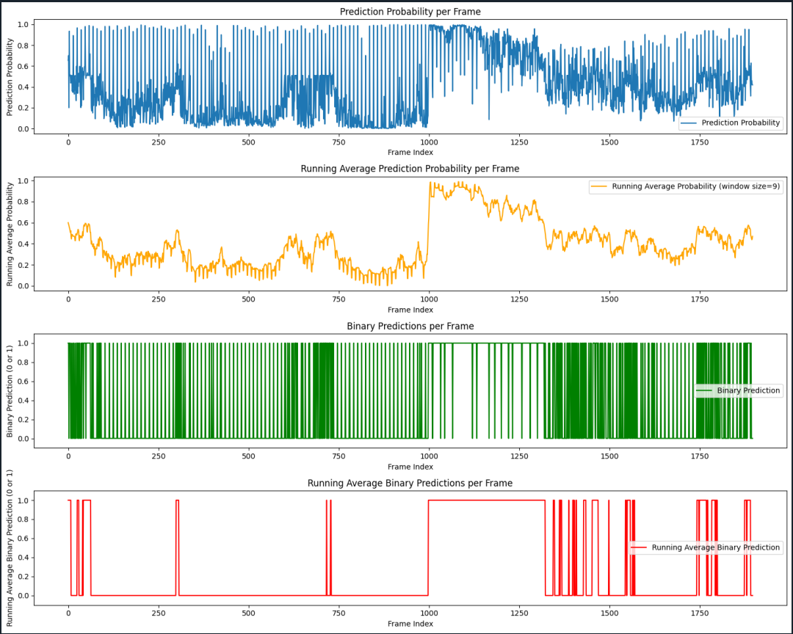

Hstack images:

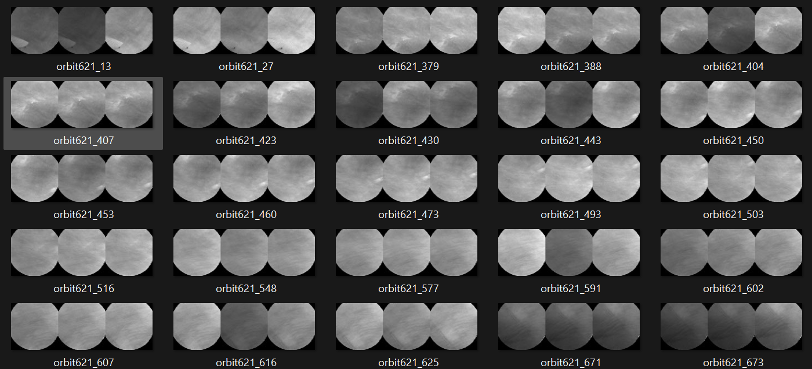

Images in one stack may have different brightness due to different normalization boundaries. 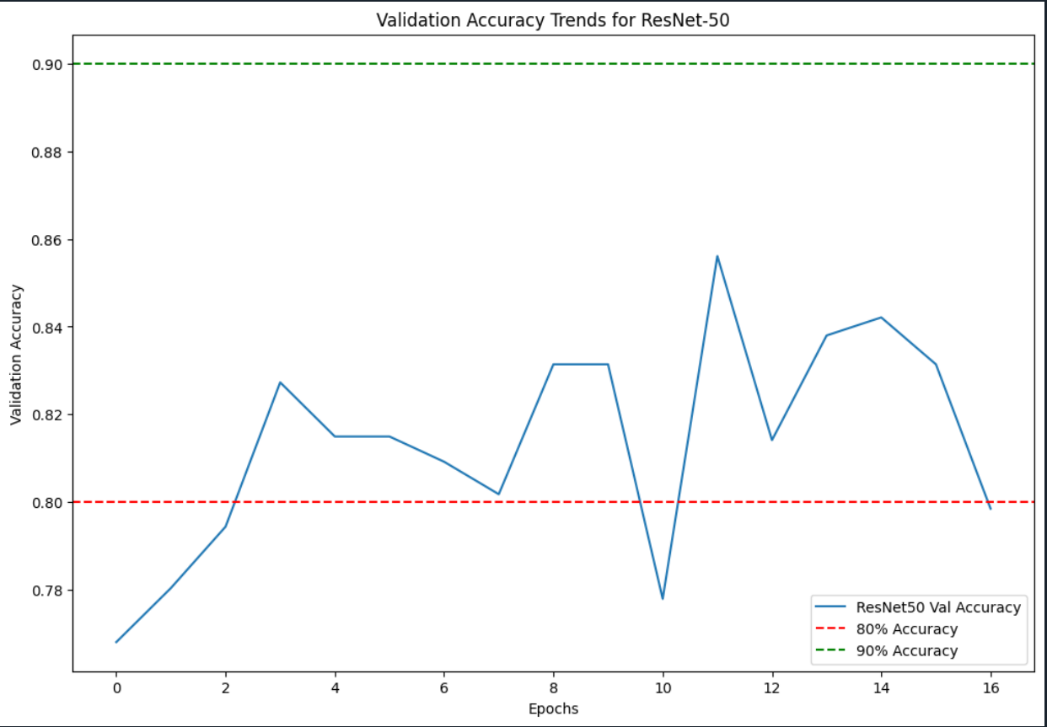

Working Model July 2: (NORM_MINMAX)  
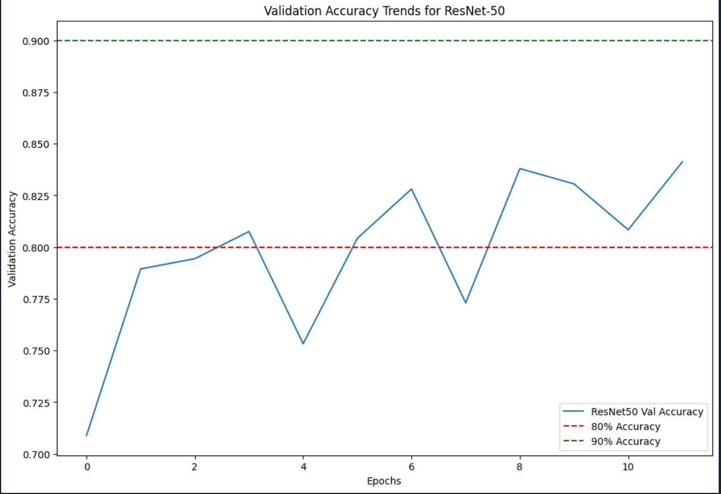

Change the normalization from min-max radiance of a frame to [0, 24] (Jiarong: 0-18)

Having a big max value may reduce the number of features displayed => make the training less efficient.

By setting the limit, the validation accuracy increased:

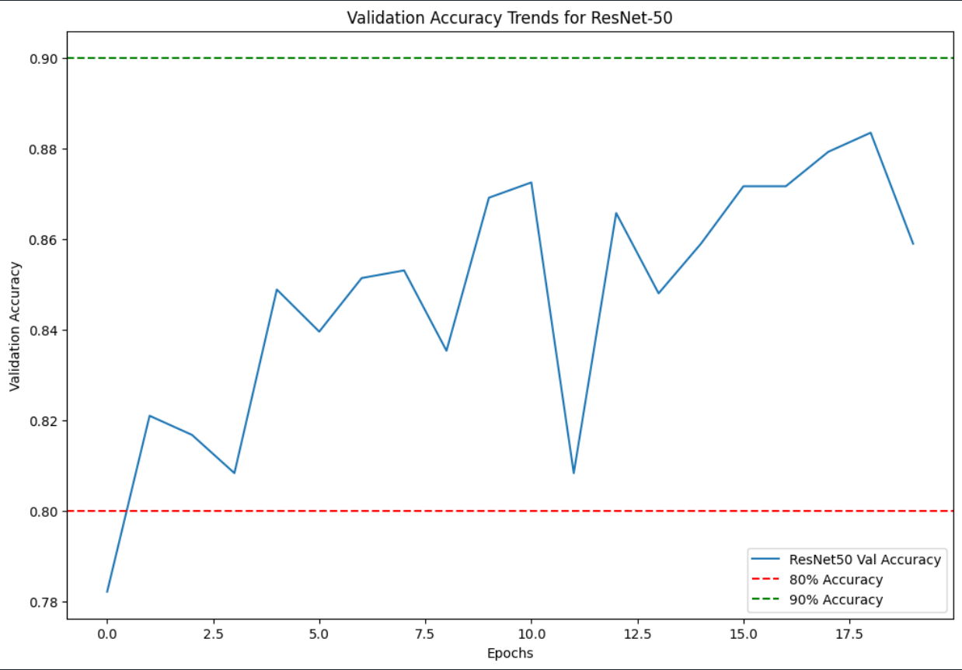

Collaboration using Github with Dallin.

Try optical flow or Long Short-Term Memory

Try only optical flow.

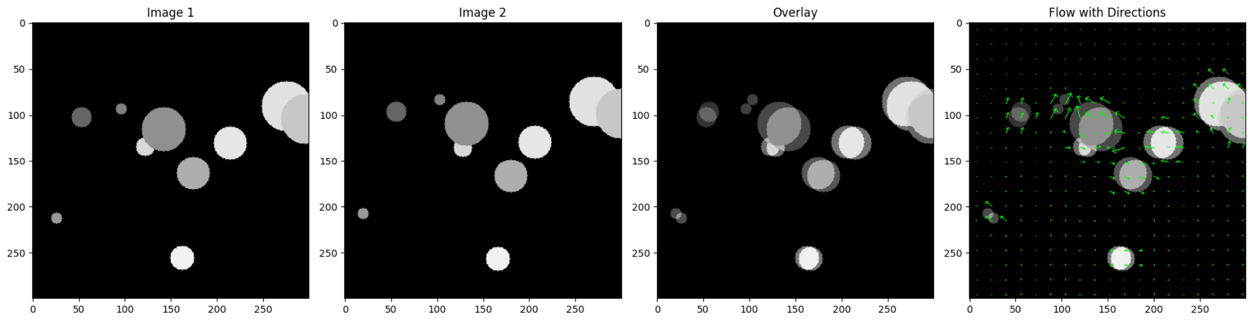

The explanation for the three channels and their role in optical flow visualization:

1. **Hue (H) Channel**:
   * Visualizes the direction of motion.
   * Different hues represent different directions.
2. **Saturation (S) Channel**:
   * Represents the intensity of the color.
   * Often kept constant in optical flow visualization to maintain color intensity.
3. **Value (V) Channel**:
   * Represents the magnitude of motion.
   * Brighter values indicate higher speeds.

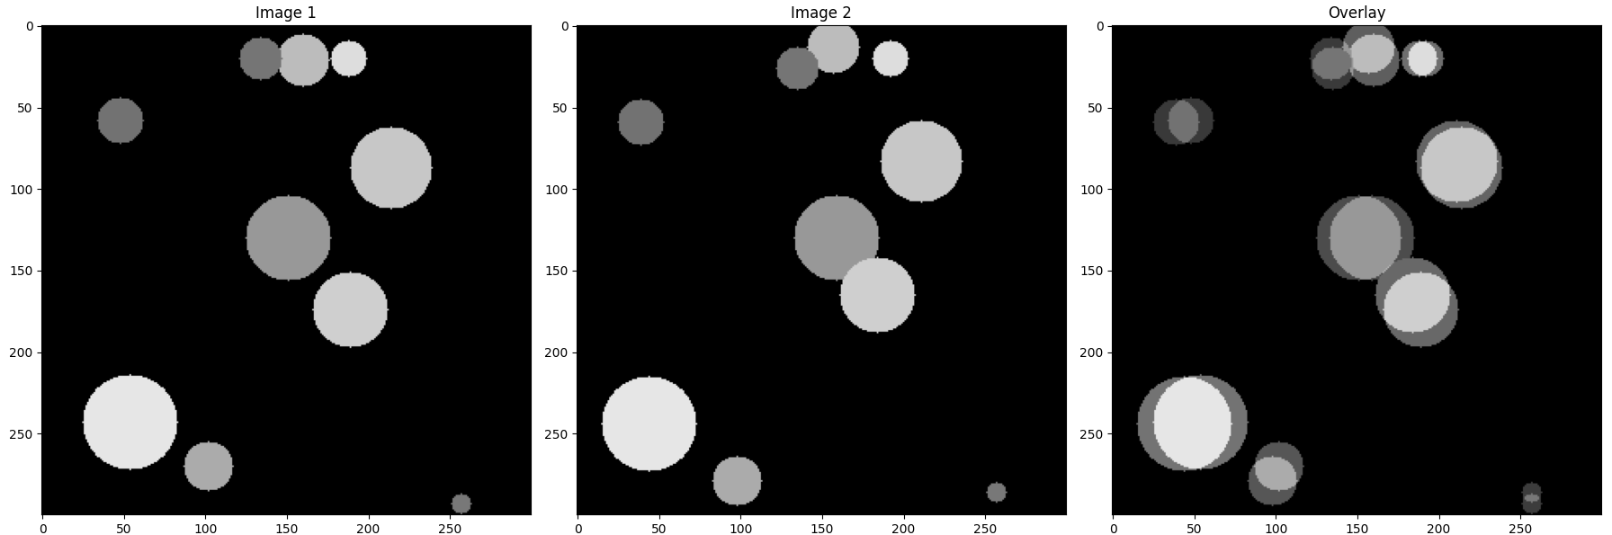

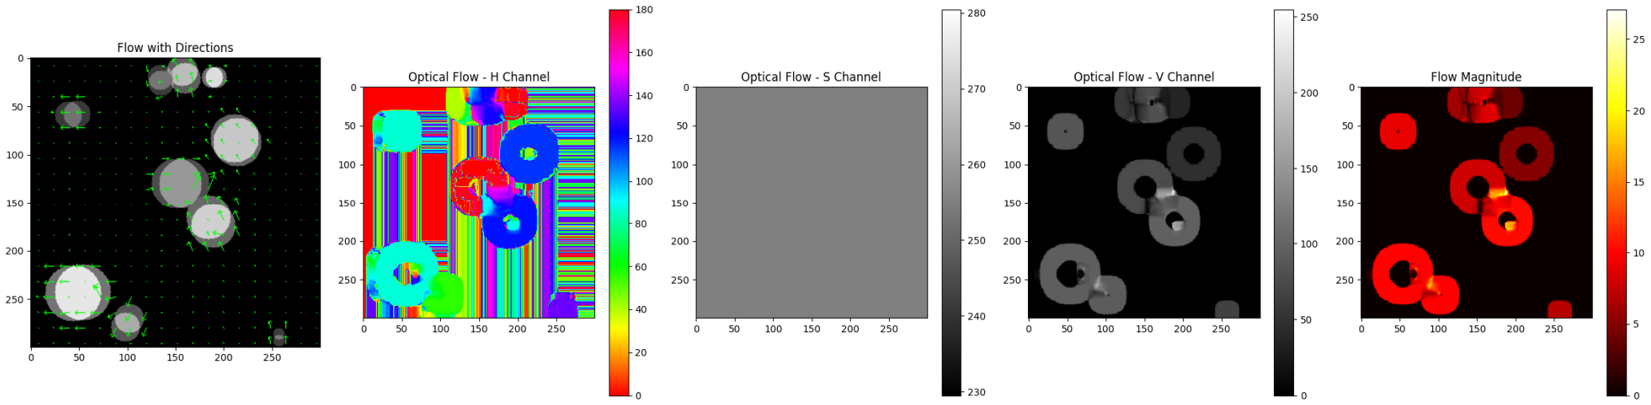

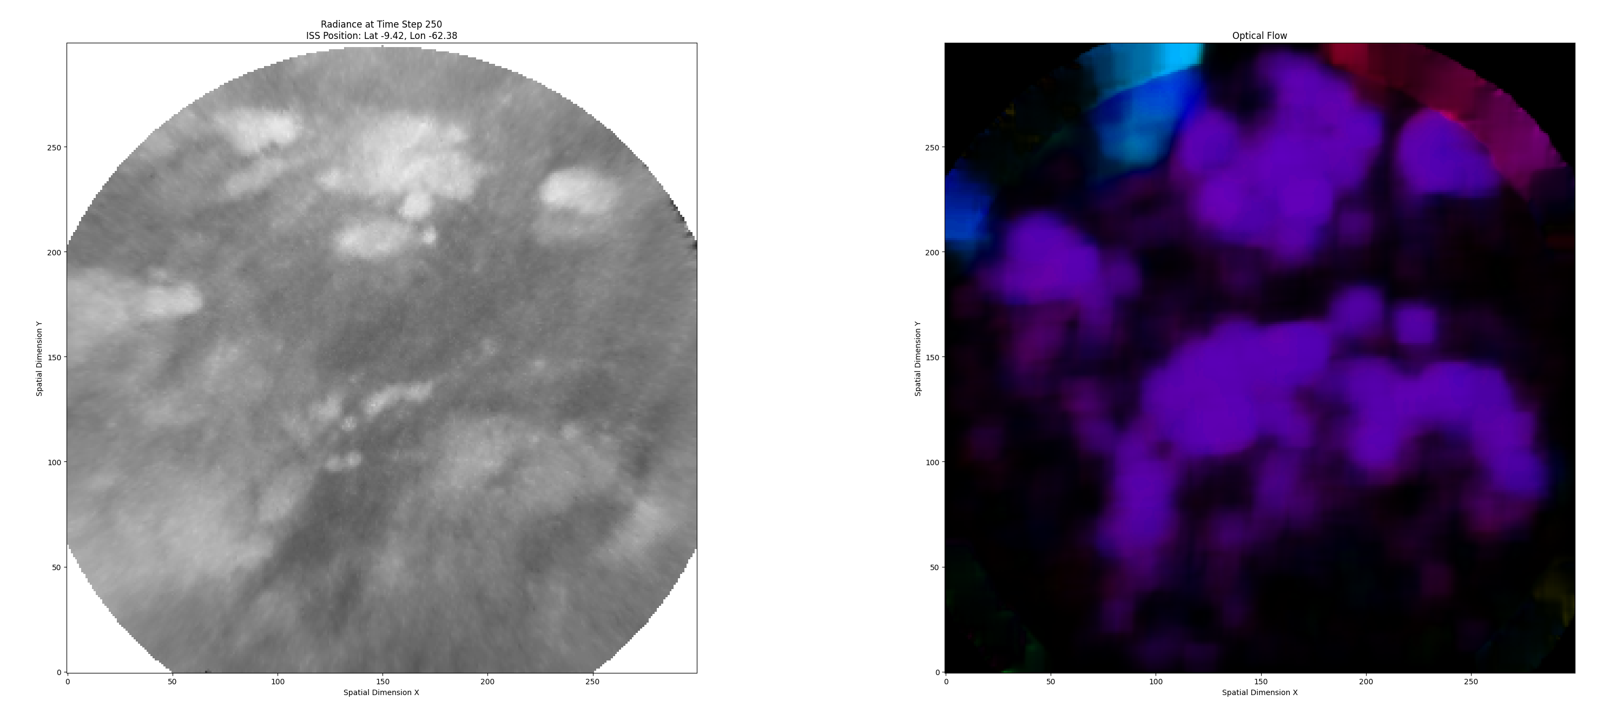

**Version 1: Utilizing three layers:**

1. Radiance data.
2. Optical flow over 4 frames (V channel).
3. Optical flow over 2 frames (V channel).

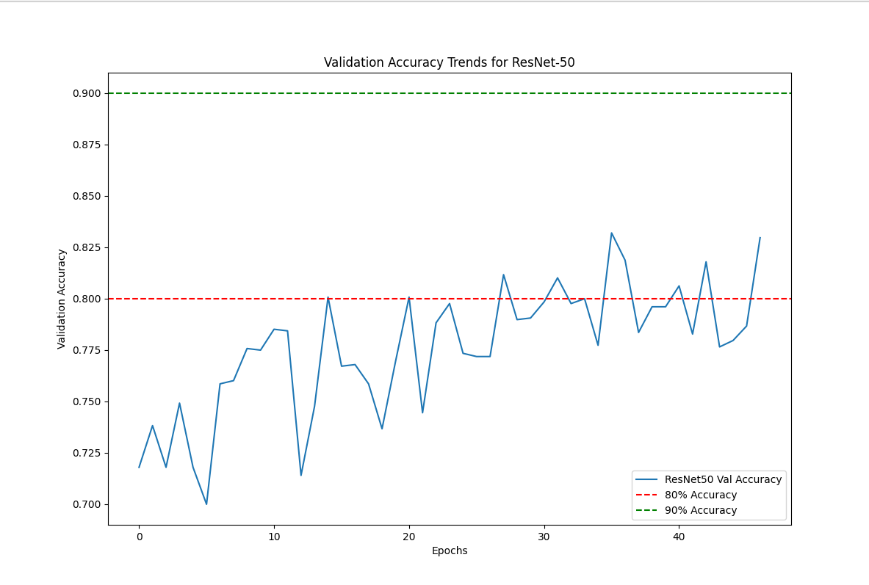

ResNet-50 is a powerful and commonly used convolutional neural network (CNN) architecture that has been highly successful in a wide range of image classification tasks. However, it is primarily designed for natural images with three RGB channels.

Task: Normalize

**Version 2: Employing three layers** (with normalization applied to the previous frame)**:**

1. Radiance data.
2. Optical flow over 5 frames (H channel).
3. Optical flow over 5 frames (V channel).

Sometimes the relative movement is apparent. Most of the times it is not.

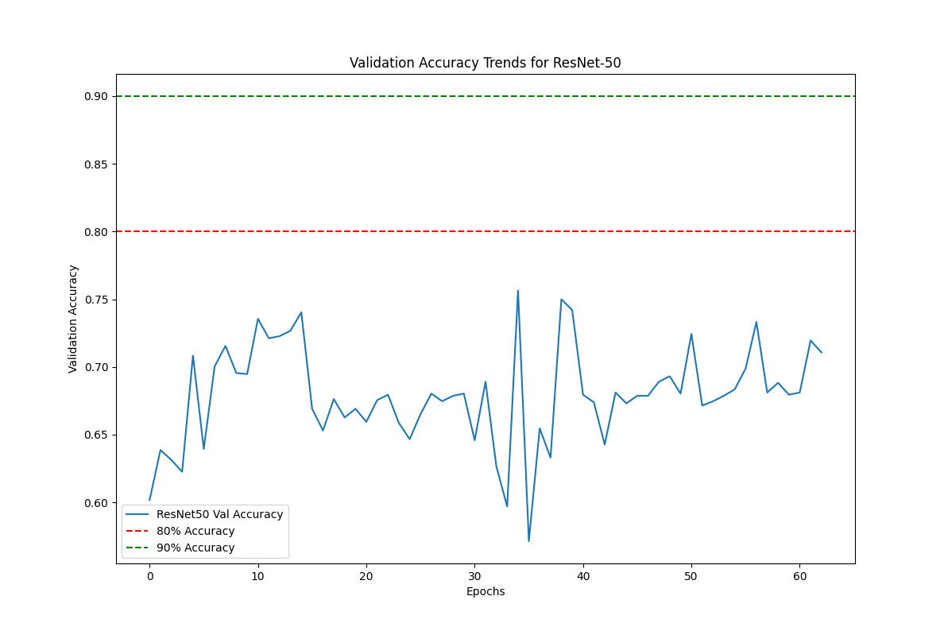

Version 3: Utilizing 3 layers of radiance data

1. Radiance data 5 frames before
2. Radiance data of that frame
3. Radiance data 5 frames after

Cloud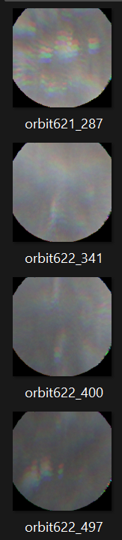 Clear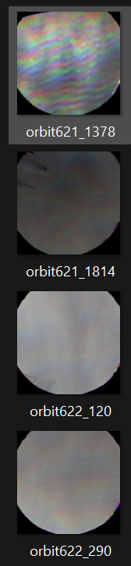

Accuracy of ML, three layers:

